**ML ASSIGNMENT 3 REPORT**

Q1)

Implemented MLP

Relu

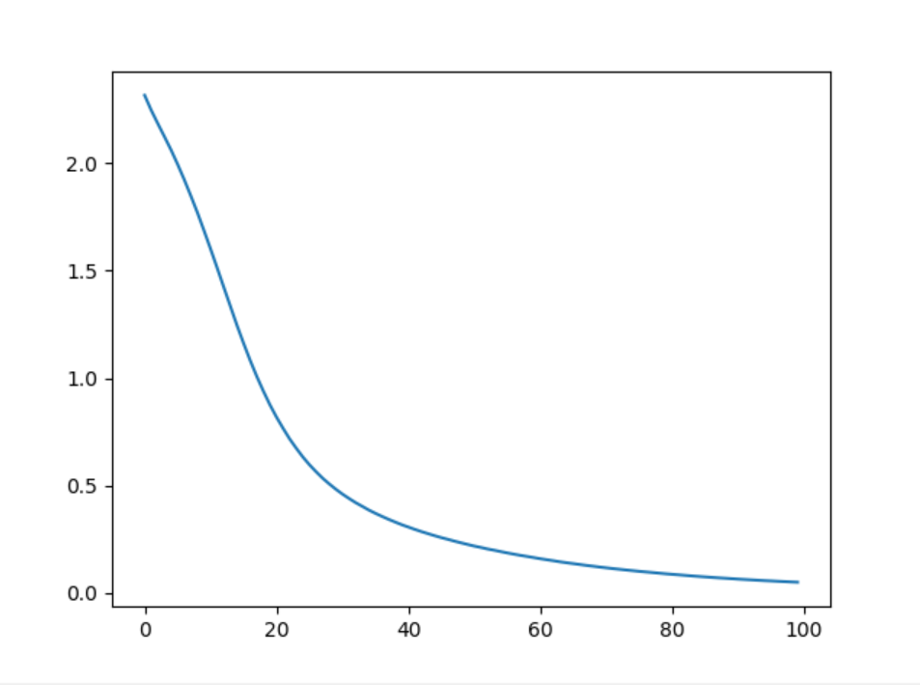

Test accuracy: 0.889700

Linear

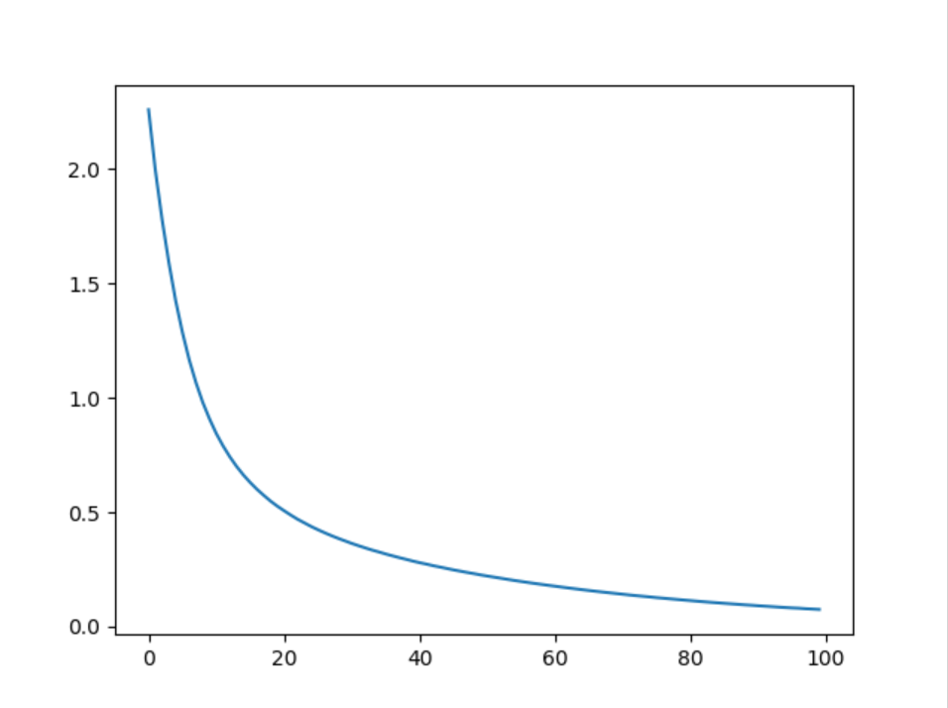

Test Accuracy: 0.855900

TanH

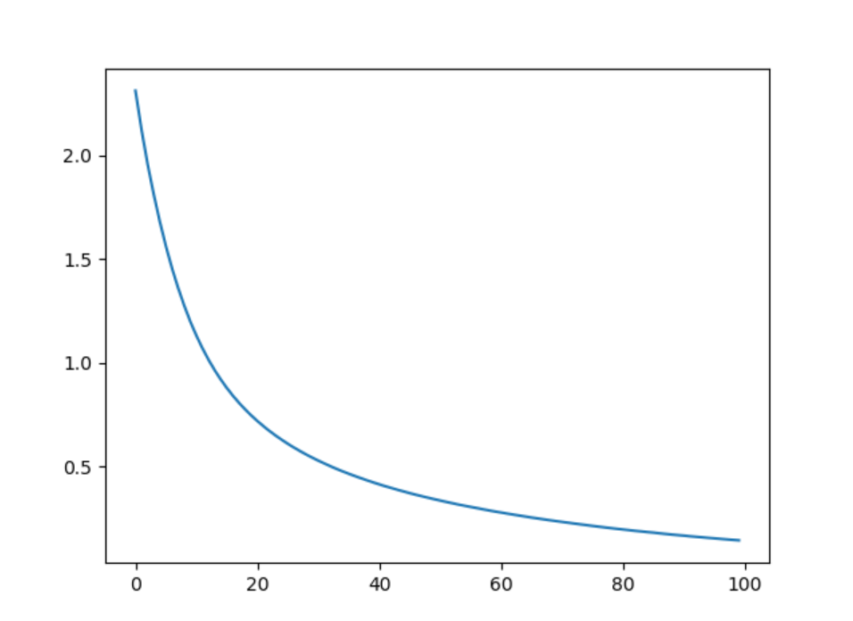

Test Accuracy: 0.869900

Sigmoid

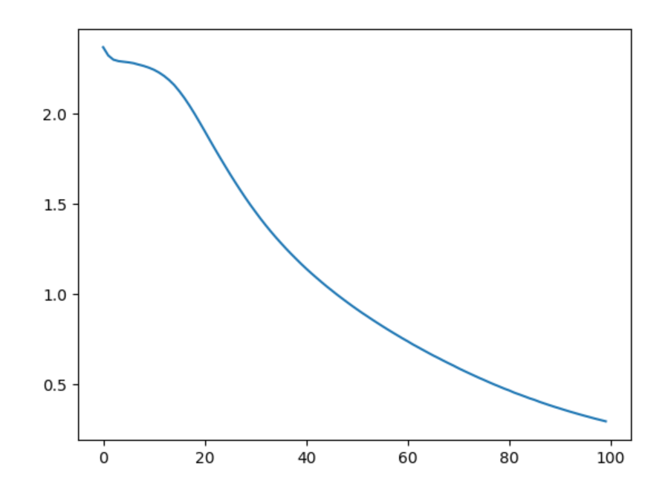

Test accuracy = 0.833400

Inbuilt Model

Test accuracy RELU: 0.975400  
Test accuracy TanH: 0.950800  
Test accuracy Sigmoid: 0.979000  
Test accuracy Linear: 0.907500